Title of the Article

Please, try to find the title compatible with the content of the paper and with journal´s focus. Maximum word number of title is 16.

maximum 5 authors

- First name Surname
Affiliation
e-mail
ORCID
- First name Surname
affiliation
e-mail
ORCID

- First name Surname
Affiliation
e-mail
ORCID
- First name Surname
Affiliation
e-mail
ORCID

- First name Surname
Affiliation
e-mail
ORCID

ABSTRACT 250-350 words

Research background: Please, describe the relevance of the research topic. 3 sentences at minimum.

Purpose of the article: Please, exactly formulate the aim of research. 2 sentences at minimum.

Methods: Please, describe the methodology, used scientific methods and data which were used in the research. 4-6 sentences

Findings & Value added: Please, present the main findings of the research a value added of the paper for economic policy and society. 8-10 sentences at minimum. Please, state the compatibility of your paper with the journal’s focus.
KEYWORDS: word, word, word, etc. [4 – 6 keywords]
JEL Classification: e.g. O11, M23, L13
Maximum size of the manuscript is 15 pages (format A4) without references. Font Arial Narrow, size 12, single line spacing. The editorial office will not accept papers that do not fulfill this requirement¹. The final number of pages could be changed only due to the graphical changes made by editorial office, ¹but the Editorial Board may decide to publish research papers with a different page range (please consult with the editor of the journal for the application of this condition).
THE PAPER STRUCTURE:
- Introduction
The authors state the aim of the research topic and its focus in general, explain its originality, and introduce its structure.
- Theoretical background
The authors evaluate the current state of the research topic on an international scale. When working on the theoretical part of the paper, the author should predominantly work with articles published in the Web of Science and Scopus databases. It is recommended to use at least 40 sources. The use of monographs is not recommended, other sources should be used minimally. Sources should not be older than 10 years, at least 50% of sources are not older than 5 years.
- Research objective, methodology and data
This part of the paper states its aim, detailed methodology and data used. The title of the paper must be compatible with its aim and its content. Using of sophisticated statistic methods is needed. Authors can use descriptive statistics as well.
- Results and discussion
The author introduces research results that should be obtained using sophisticated statistical methods, then interprets them in an economic manner, while comparing them with sources listed in the theoretical part, or justifies the excellence of his/her own results. This part should cover a comparison of results with other international results.
- Conclusion
The author evaluates whether the aim of the paper was fulfilled and presents the main findings of the research. Limitations of the research/results and a direction for further research should be explained.
FORMATING GUIDLINES:

Title of a chapter
The text of the contribution should be divided into main chapters, listed and divided above in “The Paper Structure”. If needed, authors are able to use subchapters with maximum two-level numbering. Please, use following format:
for title
- Title
for subtitle
  - Subtitle

BODY TEXT
Body text of the manuscript should be formatted as this paragraph: font Arial Narrow, size 12 and 1.0 spacing with edge alignment. Use "." as a decimal separator when specifying numbers.

FIGURES
Tables and figures should be numbered and pertaining references must be included in the text. The acceptable labeling for a table is Tab.1 and Fig. 1 for a figure (graph, picture, scheme, etc.). The title of the table or figure have to be on the top of the figure / table. Source have to be located under the table / figure.
Due to subsequent graphical processing, it is necessary to insert a link to the figure / table in the text in template as follows “see Tab. 1. / Figure 1.” and state the formula in bold “<INSERT TAB 1. / FIGURE 1. HERE>” before each visual.
The text should be composed in such a manner that there are not too many figures or tables on a single page. Tables and figures in a landscape format are not acceptable.
Font style of the table is Arian Narrow, size 12. Tables and figures have to be formatted to the center.
Use "." as a decimal separator when specifying numbers.

Tab. 1 – The title of the table.
Head of the | table have to | be in bold | And grey | background
Body of the | Table have to | Be in regular | Style [no bold, | No italic, etc.]
Source: own research

Figures and tables should be supplied in a sufficient quality, which is the responsibility of the author.

Fig. 1 – The title of the figure.
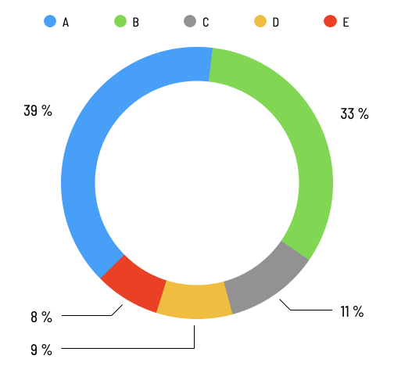
Source: own research

Equations and formulas are denoted by numbers in round parentheses and it is recommended that they are produced by Editor of equations (in MS Word) or inserted in a .jpg or .png format.
REFERENCES GUIDLINE
In-text citations and the Reference list should follow the referencing style used by the American Psychological Association (APA style). Details concerning this referencing style can be found at http://www.library.cornell.edu/resrch/citmanage/apa. Authors can also use a citation machine at http://citationmachine.net/ or use (e.g.) a Mendeley software available at https://www.mendeley.com.

IN-TEXT CITATIONS
1 author: Stein (2018), two authors Stein & Kinski (2018), three or more authors Stein et al. (2018).
If the reference is at the end of sentence: 1 author (Stein, 2018), two authors (Stein & Kinski, 2018), three or more authors (Stein et al., 2018).
References should be arranged first alphabetically and then further sorted chronologically, if necessary. More than one reference from the same author(s) in the same year must be identified by the letters "a", "b", "c", etc., placed after the year of publication*.
Authors are required to complete the referencing using DOI (Digital Object Identifier) if it has been assigned to the publication. To search for the DOI, please visit: http://www.crossref.org/guestquery/
Notes under the line are not acceptable.
Citations of author’s own papers are accepted only in a reasonable quantity.
Contributions written by an international team of authors are preferred.

References
References of academic journals used to have functional DOI code (if it has been assigned to the publication). The DOI link if references is underlined and in blue colour. It is required to check functionality of DOI link by authors.
Belas, J., & Rahman, A. (2023). Financial management of the company. Are there differences of opinion between owners and managers in the SME segment? Journal of Business Sectors, 1 (1), 1-9. https://doi.org/10.62222/UQAH6943 (article)
Stein, J., Kinski, P., & Schmidt, S. (2023, a). Financial management of SMEs. Journal of Business Sectors, 1 (2), 1-12. http://dx.doi.org/10.1000/BF0012345 (article)
Stein, J., Bauer, T., & Falkner, S. (2023, b). Corporate Social Responsibility in SMEs Segment. Journal of Business Sectors, 1 (3), 102-115. http://dx.doi.org/10.1000/BF0012345 (article)
Hoffer, J. et al. (2020). Financial management of company. Berlin: ALT Press. (monographs)
European Commission. (2020). The importance of small and medium-sized enterprises. Brussels: European Commission. Retrieved: October 9, 2022, from http://ec.europa.eu/enterprise/policies/sme/files/sme_definition/sme_user_guide.pdf.
more examples at http://www.library.cornell.edu/resrch/citmanage/apa

